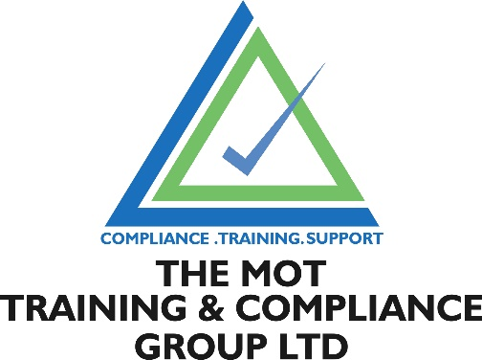

The VTAA (Vehicle Technician Accredited Assessment) course is usually used by technicians who wish to become MOT Testers and have the required knowledge/experience but no paper qualifications.

Please make sure if you are wishing to go on to take the IMI Award in MOT Testing (Class 4&7) that you can tick the following boxes
I have 4 years’ experience in the maintenance and repair of light vehicles
I regularly carry out the following activities for maintenance and repair
- Suspension

- Engine ignition/emissions

- Braking Systems

- Steering
I regularly carry out diagnostics for all vehicle system activities as listed above
I hold a full UK driving licence for the MOT classes I wish to test

If you are not wishing to go onto the MOT Tester training please contact us to discuss your requirements. 0800 1777 344.

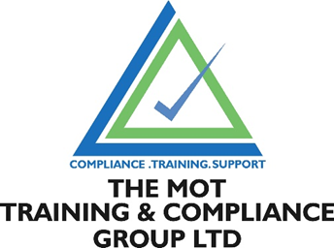

APPLICATION FOR LVI ONE DAY COURSE
APPLICANT DETAILS

NAME

FULL ADDRESS & POSTCODE

PHONE

EMAIL

DATE OF BIRTH

DRIVING LICENCE NUMBER

NAME & ADDRESS OF EMPLOYER FOR INVOICING

EMAIL ADDRESS FOR INVOICING
DATE OF TRAINING

Please forward the completed form with a copy of your driving licence to lisa@themotgroup.co.uk

Please ask your employer to email a letter confirming your workshop experience in a separate email something along the lines of:

To whom it may concern

I can confirm that ...................... has been employed at ..........................since ...................... and has, therefore, the 4-year full time workshop experience required to be an MOT tester

He is a competent and experienced technician.

Signed

Name
Position

Or words to that affect, please feel free to use your own words if you would prefer. If you work for yourself, please word it something along the lines of:

To whom it may concern…
I can confirm that I have been employed at (Your company name) since .............and I have experience in suspension, transmission, engine, air conditioning, braking, steering and diagnostics, I have the 4-year full time workshop experience required to be an MOT tester and take this course.
I hold a total of .............years’ experience in the motor trade. I am a self-employed technician, and I consider myself competent and experienced.

Name
Position

Please forward the completed form with a copy of your driving licence to lisa@themotgroup.co.uk

